## Executive Summary

The Barangay Project is a Web-based application that can store, receive, accept and process data of the user. These features fit perfectly to help citizens of the Philippines to easily experience the services being offered by the government and making use of the technology to their own advantage. With “helping Filipinos” in mind, developers were asked to create a system that helps the lowest form of the government which is the barangay. Every barangay in the Philippines provides services to their constituents. But with the Barangay Project, we bring “providing of services” to a whole new level. Government services that the barangay provides will be available online. From requesting an ID, clearance, business permit, submitting documents, to postings of current news, events and happenings in the barangay. And of course the system’s security will always be a top priority. That is why registration and approval are a critical part of the systems features and a requirement in order for users to actually use the system.

## Introduction

### Client’s Mission and Objectives

The client’s mission in this project aims for the better Philippines and how this project can impact the lives of every Filipino by making use of the latest and existing technologies to reach out for people and providing them services offered by the government that they needed. With the client’s vision and the developer team’s background and knowledge in computer science and information technology, the Barangay Project was made possible. The Barangay Project provides easy access to information and services that are being offered by every barangay anytime anywhere. The Project is a web-based application that can store, receive, accept and process data of every citizen who wishes to make use of its service and at the same time inform the citizens by providing educational learning and latest happenings in their respective barangays. This Project is just a small part of a much bigger picture and a bigger project in progress in which every citizen in the Philippines gets to have their own personal identification recorded and stored.

### 

### Project Objectives

The system’s objective is to create organized and secured information details for the barangay citizen to provide fast and accurate transactions. Help lessen complications in the manual processing such as information redundancy caused by repetitive registration and avoid missing data thus leading to successful document processes. The system also aims to educate the citizens by providing them with appropriate content of information and giving them easy access to this information.

### Purpose of the Project

The purpose of the Barangay System is to be as efficient as possible. It will turn the old system into an automated system. All the basic services of the barangay will be automated and all the data will be more secured and authentic. The objective of the system is to ensure efficiency and security. The application will be handled by the barangay officials and it will used by the masses. In the case of the transaction that involves payment, the citizen must go to the barangay office and pay manually. The main process of the system is to collect information and data from the citizen who will register and the system automatically displays the standard format of registration form. The bulletin’s role is to inform the citizens what are the events, news, tips, and updates of the specific barangay, also the system has the capability to give information in health, education and documents.

6. Rationale of the Project  
 a. The current process of the flow  
 - 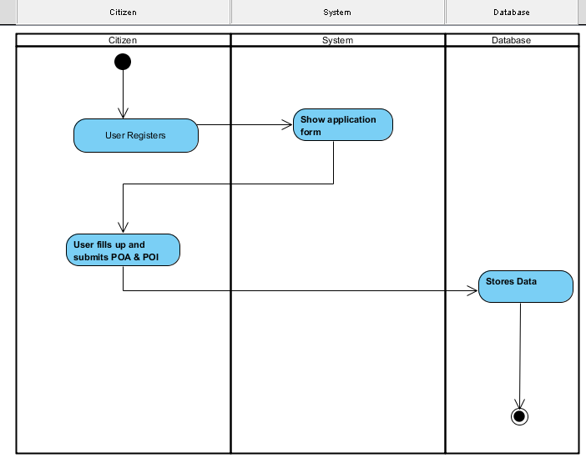  
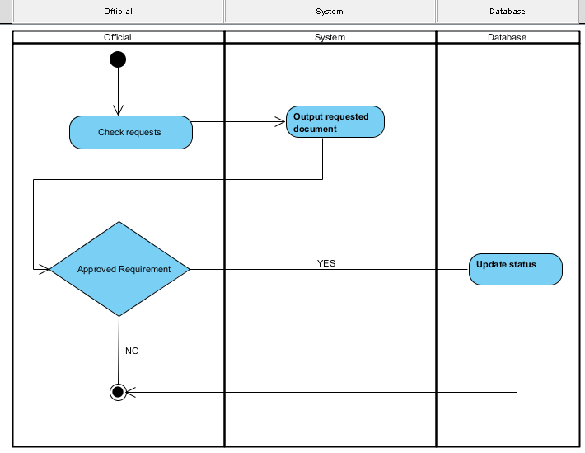  
 b. User Information Needs  
 - The user information needs registering information to the system, softcopies of Proof of Identity or Address. Examples are Meralco Bill, Maynilad Bill or Valid ID as long as there is a legit address of the citizen.   
 c. How the Information is being processed  
 - The information is processed by adding information of the citizen in the system and also the citizen can update his / her profile or make changes. The system displays the update information of the citizen.

C. System Features and Function  
1. Software Environment  
 a. Programming Languages  
 - The system make use of the HTML and CSS for the interface and design of the system and for the main function and connecting database it used PHP and JavaScript.  
 b. Specific Software  
 - In order for the system to create, it uses a COBALT framework, it’s the code generator used to create most function of the system and also creates the database. We used Sublime and Notepad++ for the text editor. As for the localhost of the system it uses XAMPP and WAMP for the PHPMyAdmin and also a web browser for the user interface. The XAMPP is also used for the connection for the mobile in order for the system will be resized in the mobile (it’s compatible in any mobile device). In editing our photos in contact and about page, we used Adobe Photoshop CS6.   
 c. Web Server Application  
 - The system used WampServer 2.5 and XAMPP (MySQL and PHP) it is a web development platform   
 used to create dynamic web applications with MySQL and PHP.  
 d. Operating System  
 - The barangay system is compatible to any operating system like Windows, Linux and Macintosh based on the fact that the system can run to any web browser.

e. Other Software  
 -

2. Hardware Environment  
 - The recommended minimum requirements are 256MB of RAM for a single-computer website and 85MB of storage with as little as 48MB of RAM.

3. Networking and Security  
 a. Security  
 b. Server  
 - The system used WampServer 2.5 (MySQL and PHP) it is a web development platform   
 used to create dynamic web applications with MySQL and PHP.  
4. Application System Modules

A. Citizen Registers  
 - The citizen must first register to the system in order to use the main function of the system like requesting basic barangay documents.  
b. Request Document  
 - The citizen can able to request basic barangay documents like barangay id, barangay clearance, and business permit and etc.   
c. Update Bulletin  
 - The system has a bulletin about the news, updates, events and happening in the barangay.

II. System Diagrams and Screenshots  
a. Data Flow Diagrams  
 1. Context Leve Data Flow Diagram  
 2. Level 0 Data Flow Diagram  
b. UML Diagrams  
 **Class Diagram** 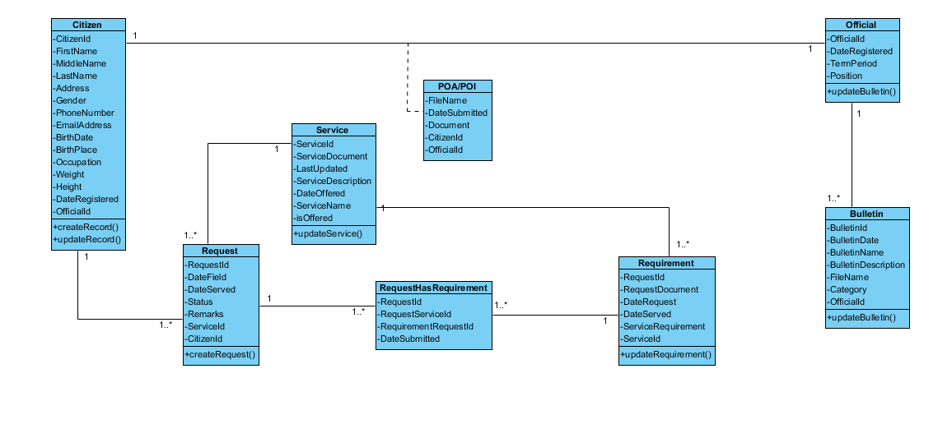

**Use Case Diagram**  
 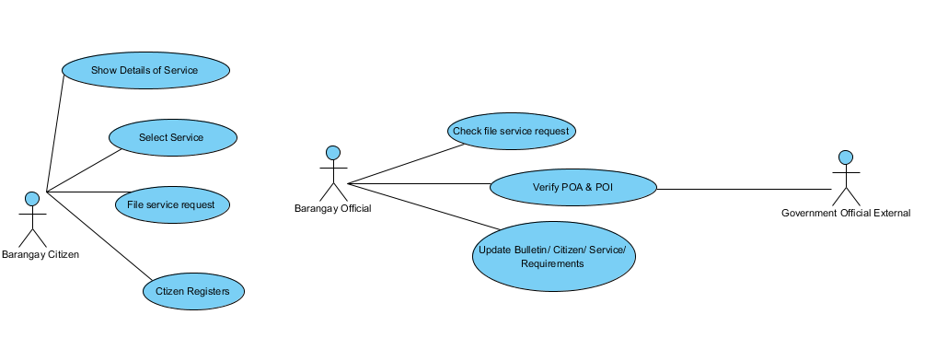  
 **Activity Diagram**  
 Select Service  
 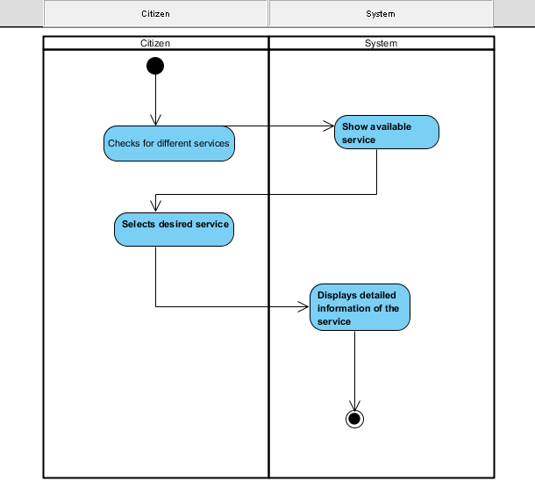

File Service Request  
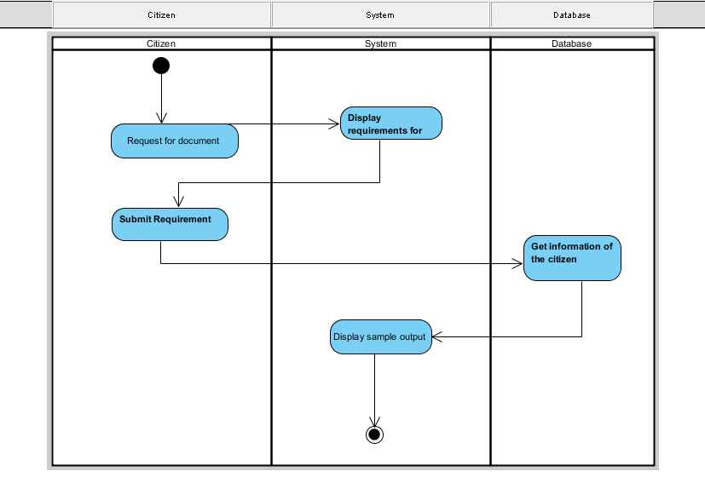

Citizens Register



Check File Service Request



Verify Proof of Identity / Address (POI / POA)

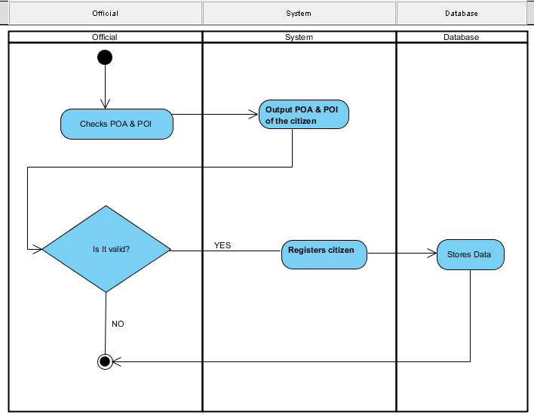

**Sequence Diagram**

Select Service

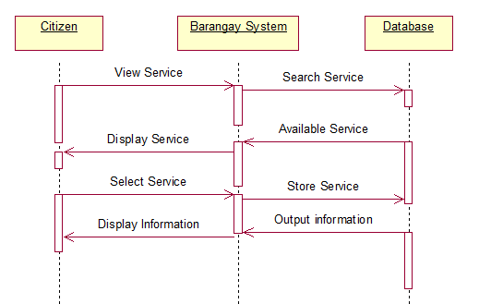

File Service Request

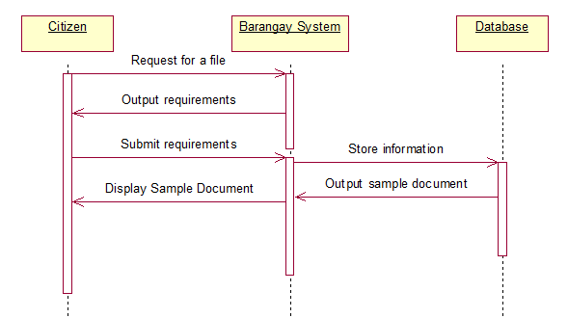

Citizen Registers

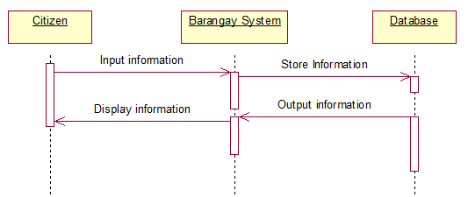

Check File Service Request

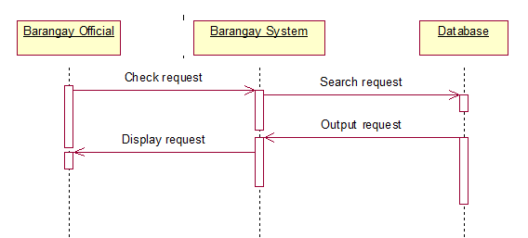

Verify Proof of Identity / Address (POI / POA)

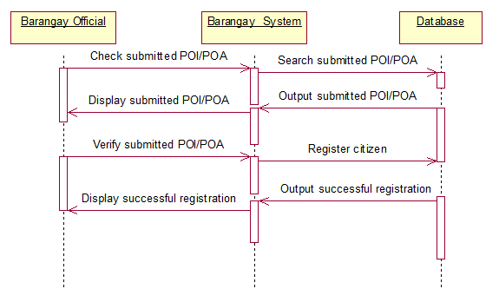

Update Bulletin

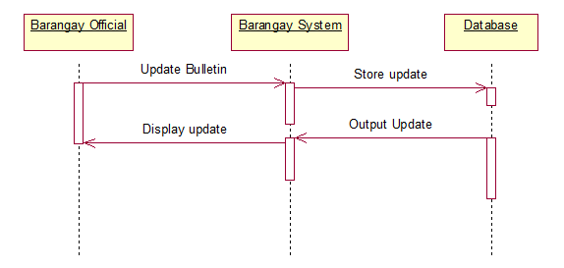

**Collaboration Diagram**

Select Service

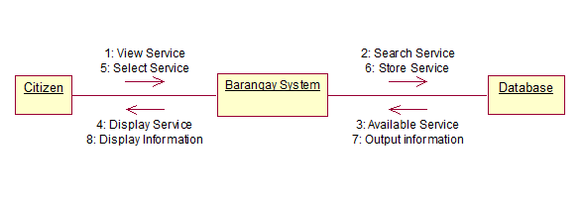

File Service Request

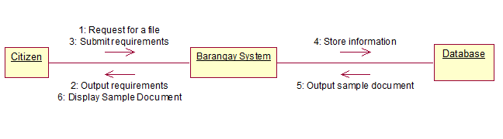

Citizen Registers

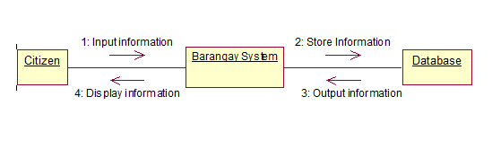

Check File Service Request

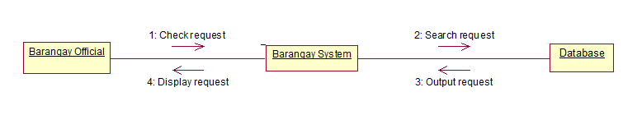

Verify Proof of Identity / Address (POI / POA)

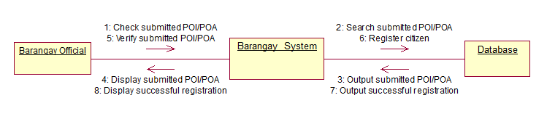

Update Bulletin

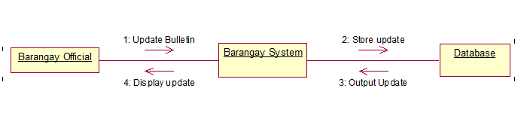

**Component Diagram**

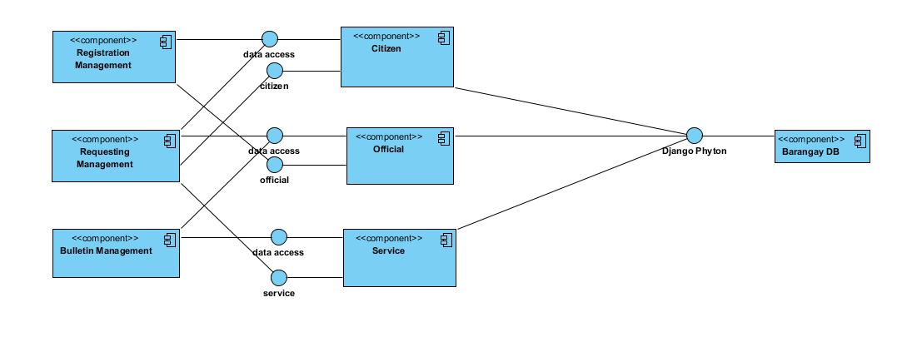

**Composite Diagram**

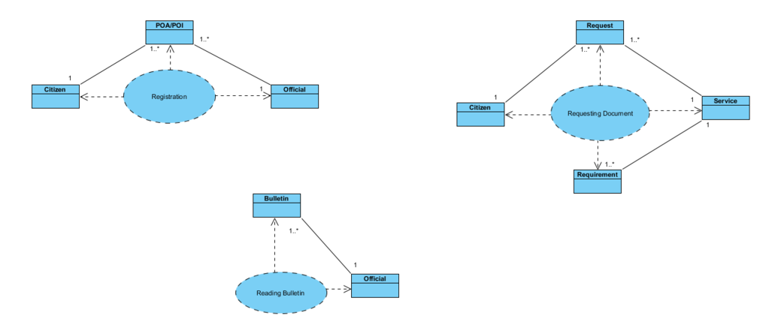

**Deployment Diagram**

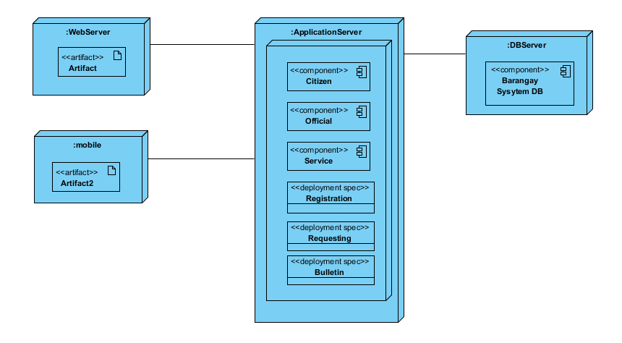

**Interaction Diagram**

Citizen Registers

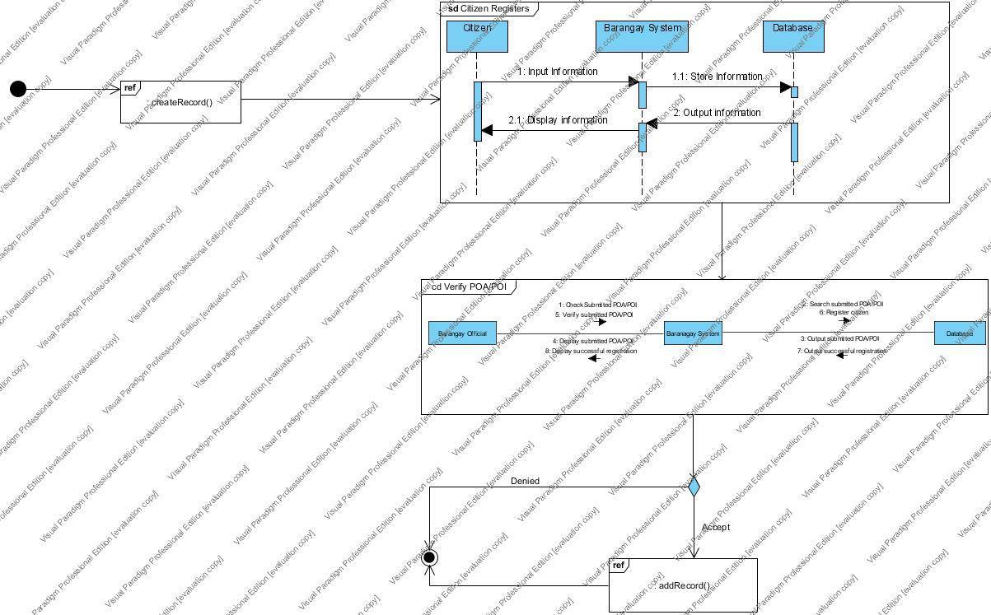

Request Document

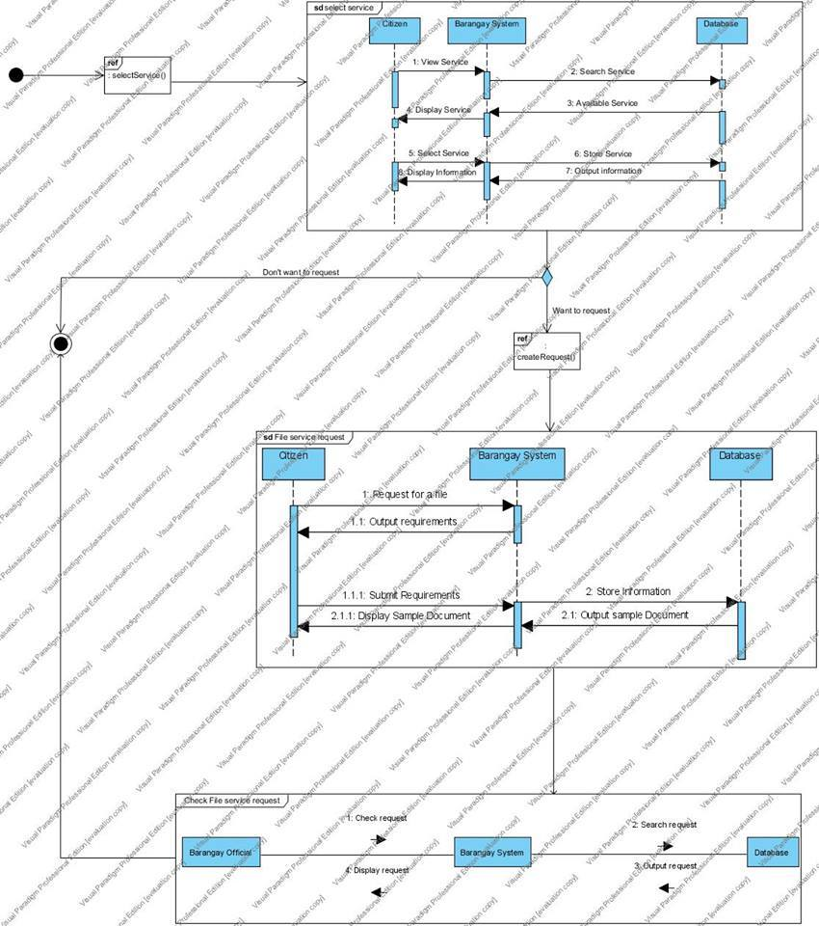

Update Bulletin

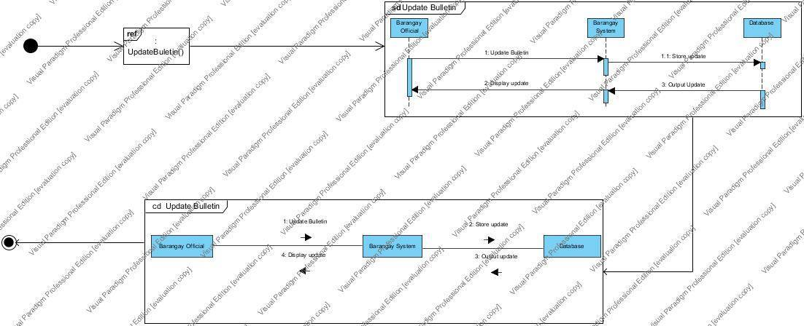

**Package Diagram**

Citizen Registers

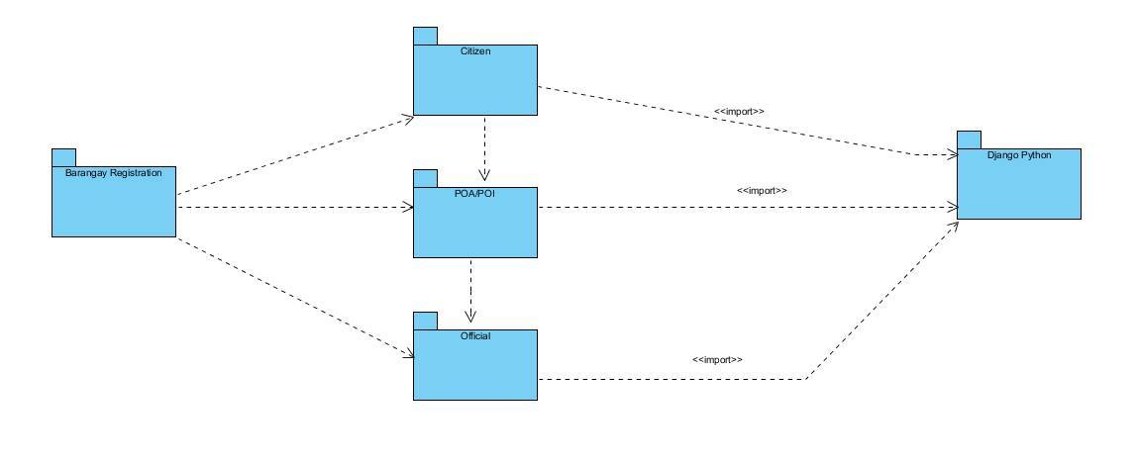

Request Document

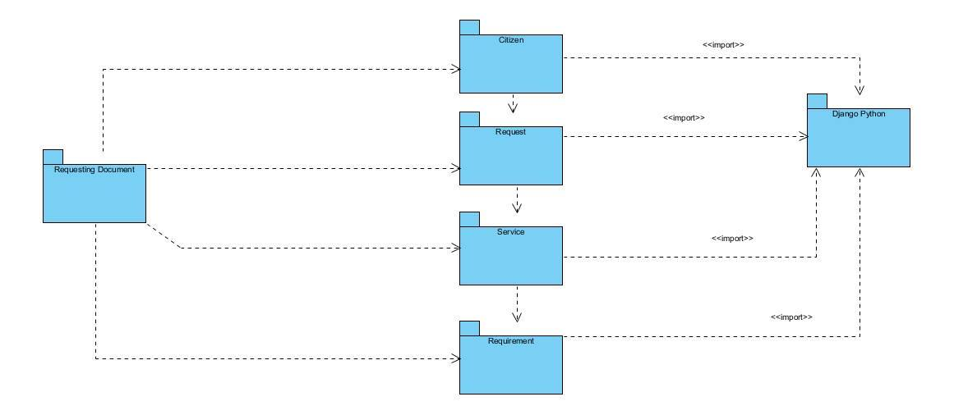

Update Bulletin

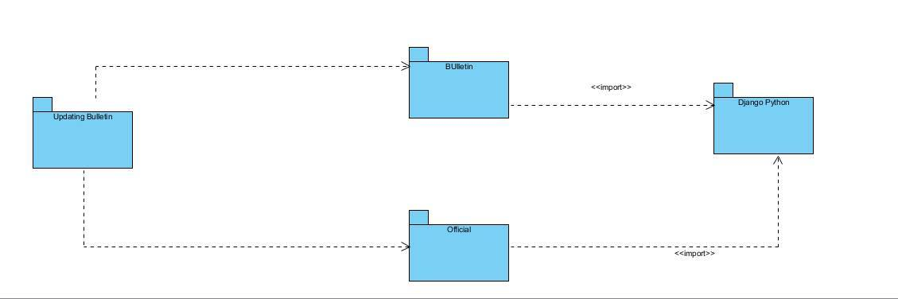

**Object Diagram**

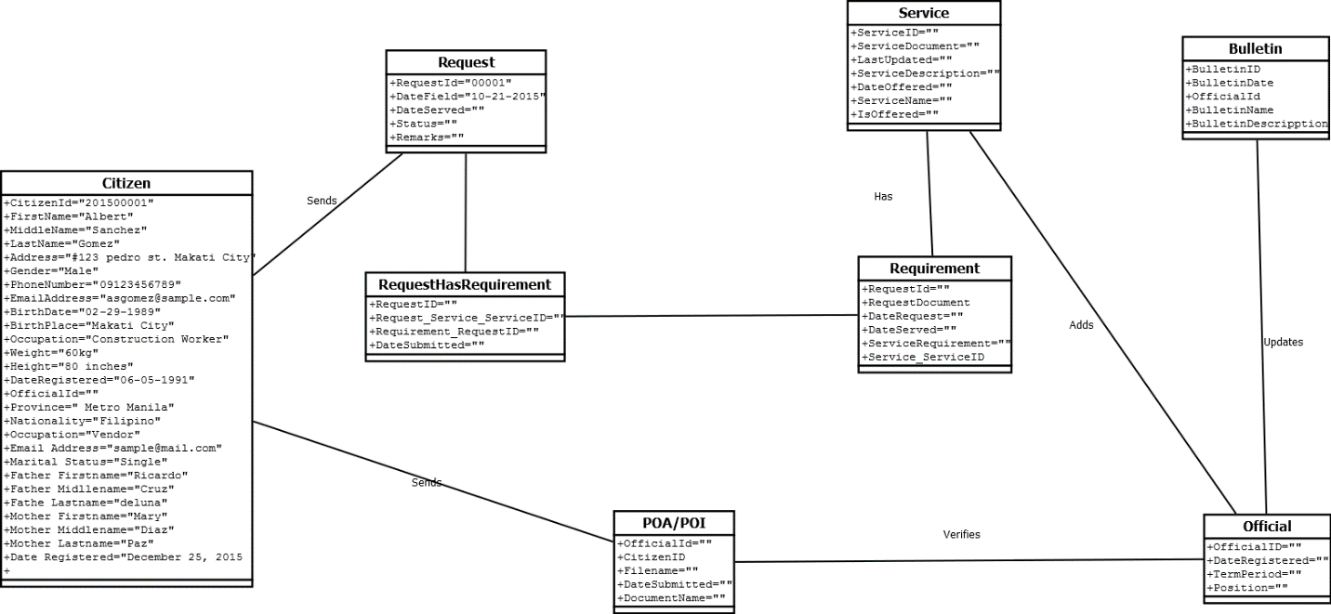

**State Machine Diagram**

Citizen Register

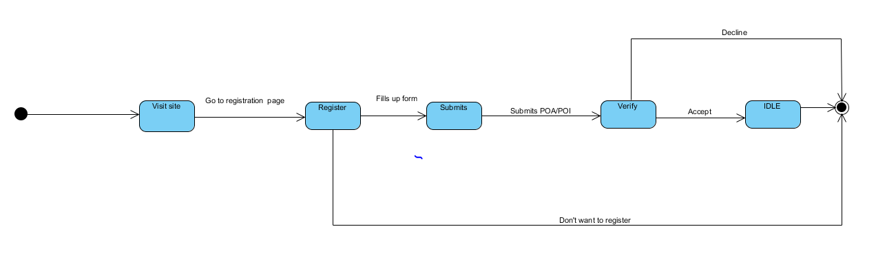

Request Document

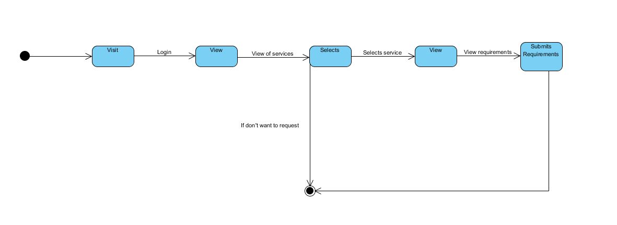

**Timing Diagram**

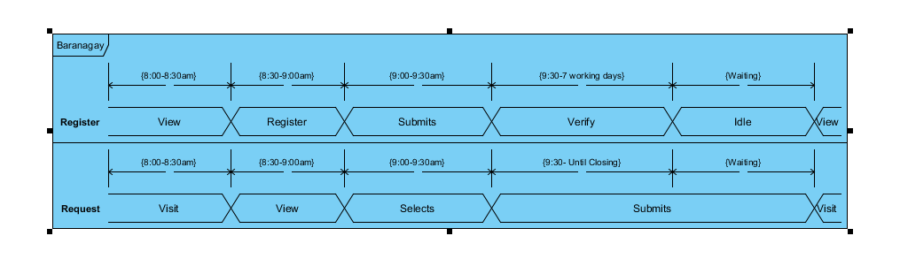

c. Entity Relationship Diagram  
d. Data Dictionary  
e. Screenshots  
f. Lesson Learn

III. Appendices